**RIP IN CLASS**

**TOPOLOGY:**

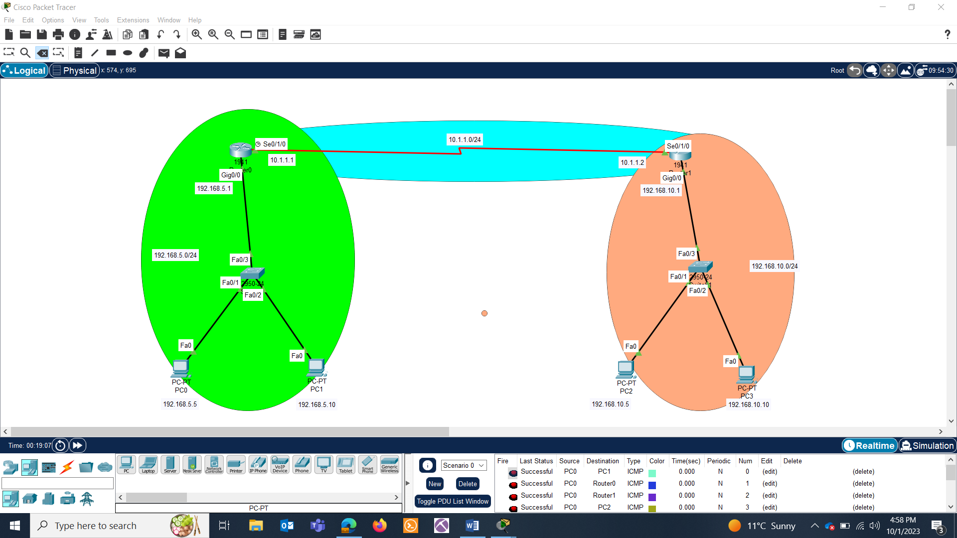

CONNECTIONS:

NETWORK: 192.168.5.0/24

* PC0(Fa0 192.168.5.5) and SW0(Fa0/1)
* PC1(Fa0 192.168.5.10) and SW0(Fa0/2)
* SW0(Fa0/3) and Router0(Gig0/0 192.168.5.1)

NETWORK: 10.1.1.0/24

* Router0(Se0/1/0 10.1.1.1) and Router1(Se0/1/0 10.1.1.2)

NETWORK: 192.168.10.0/24

* PC2(Fa0, 192.168.10.5) and SW1(Fa0/1)
* PC3(Fa0, 192.168.10.10) and SW1(Fa0/2)
* SW1(Fa0/3) and Router1(Gig0/0 192.168.10.1)

PCs configurations:

PC0:

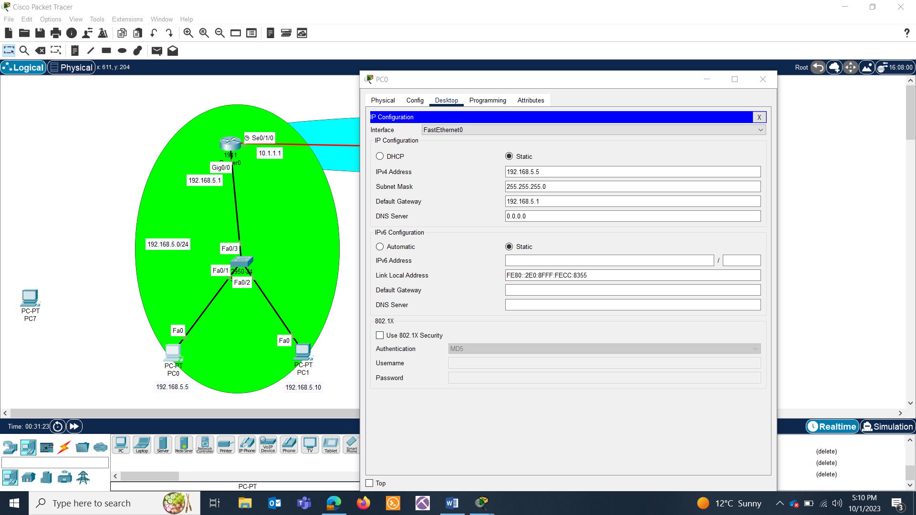

PC1:

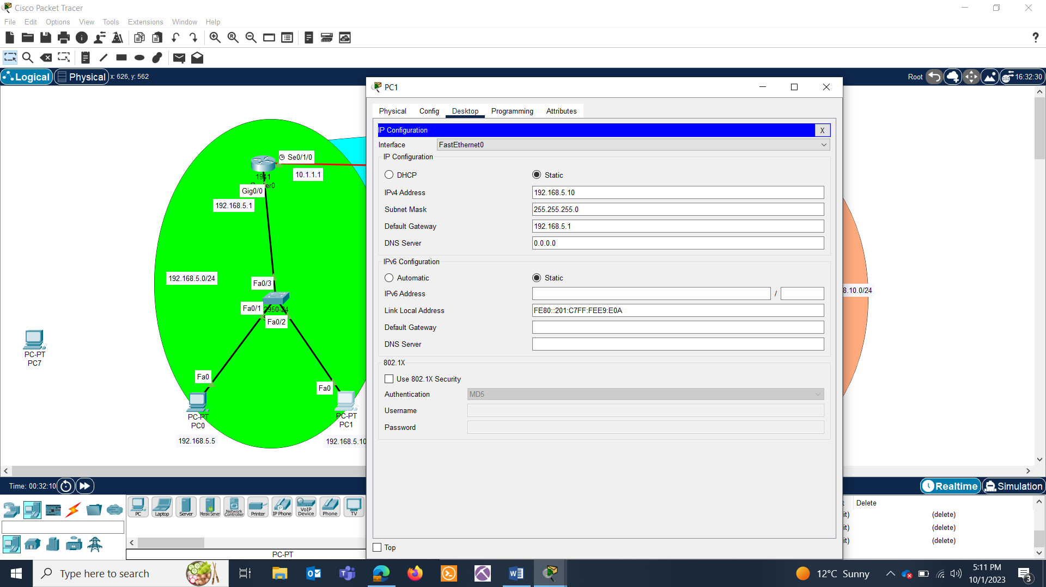

PC2:

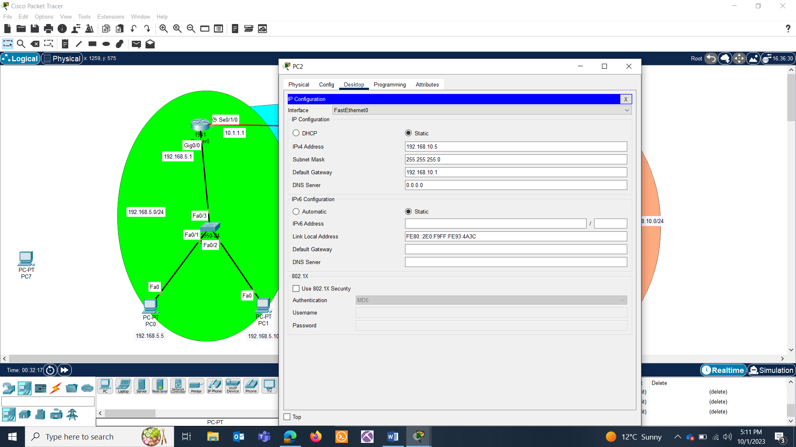

PC3:

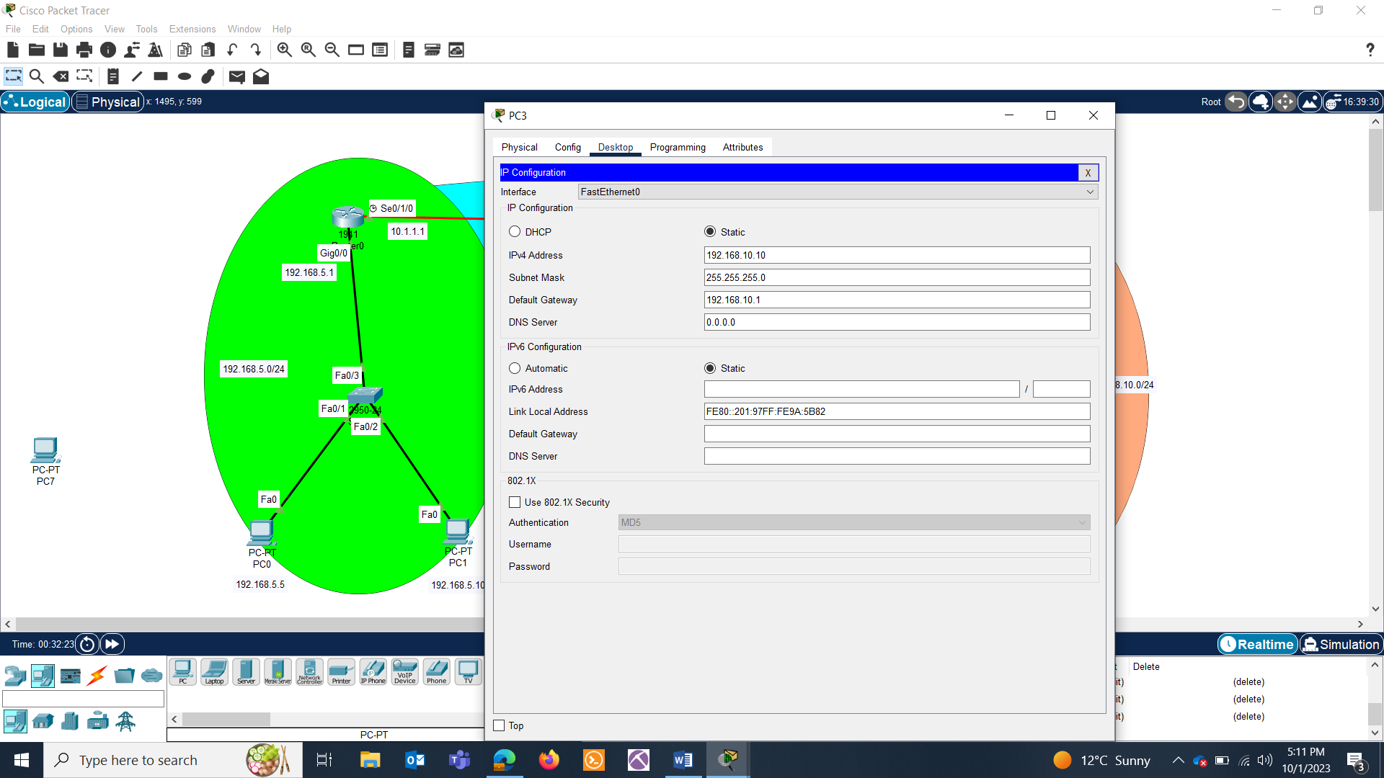

Router0:

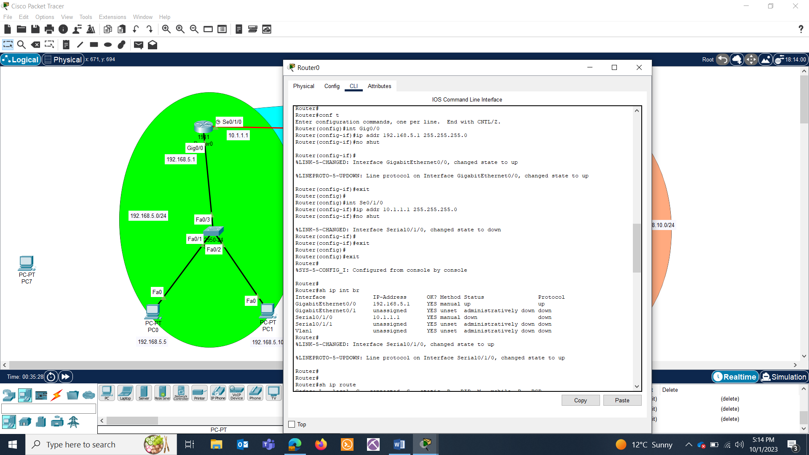

Router1:

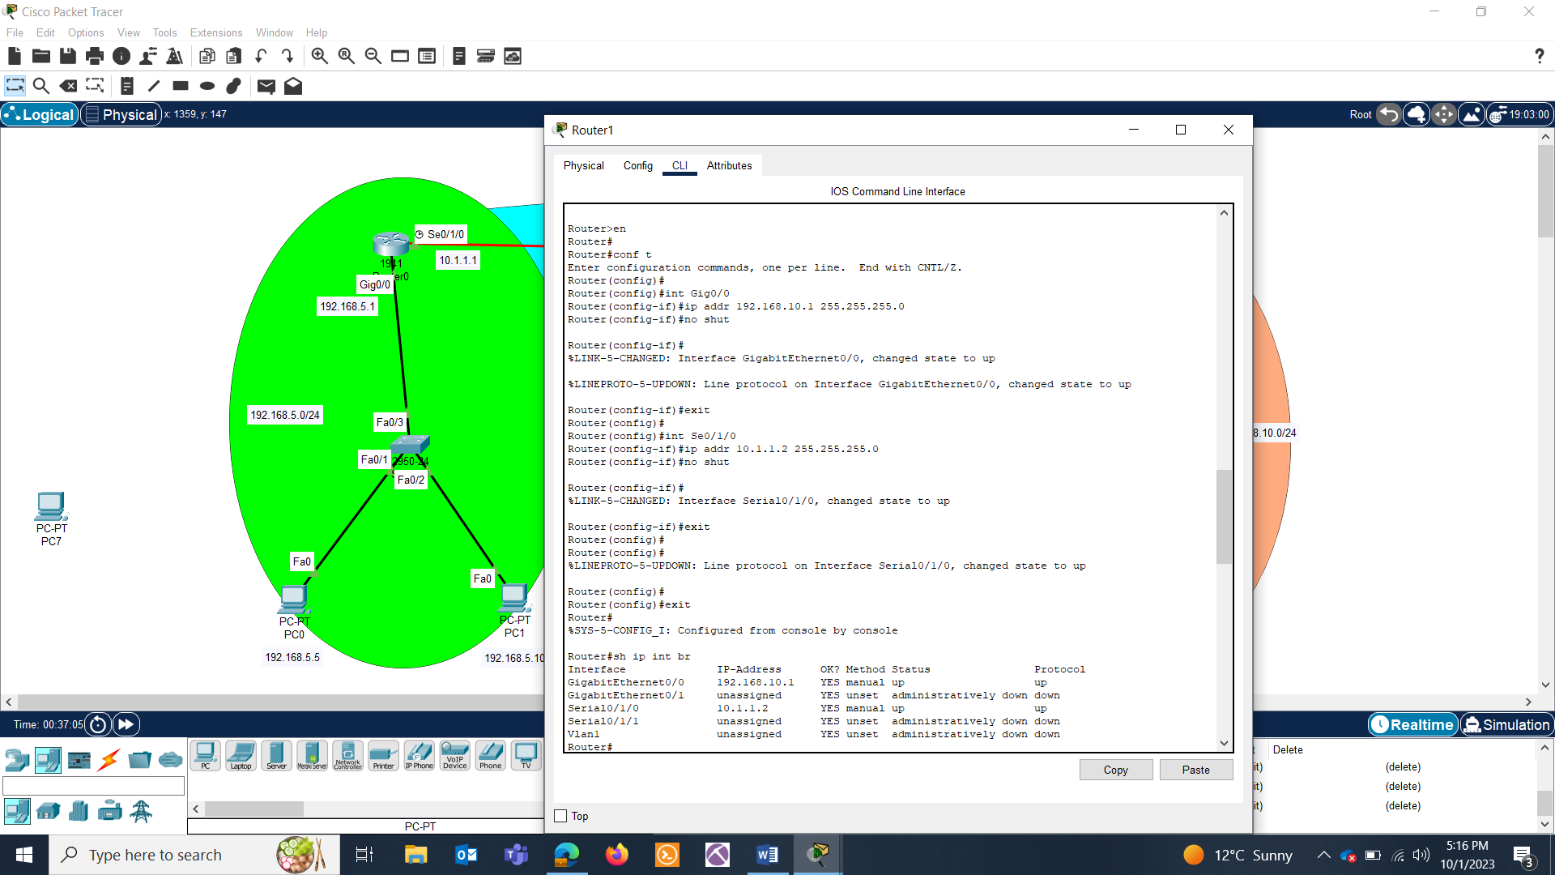

Test if you can send packets from one network to another.

No, not yet.

SETTING ROUTES:

Router0:

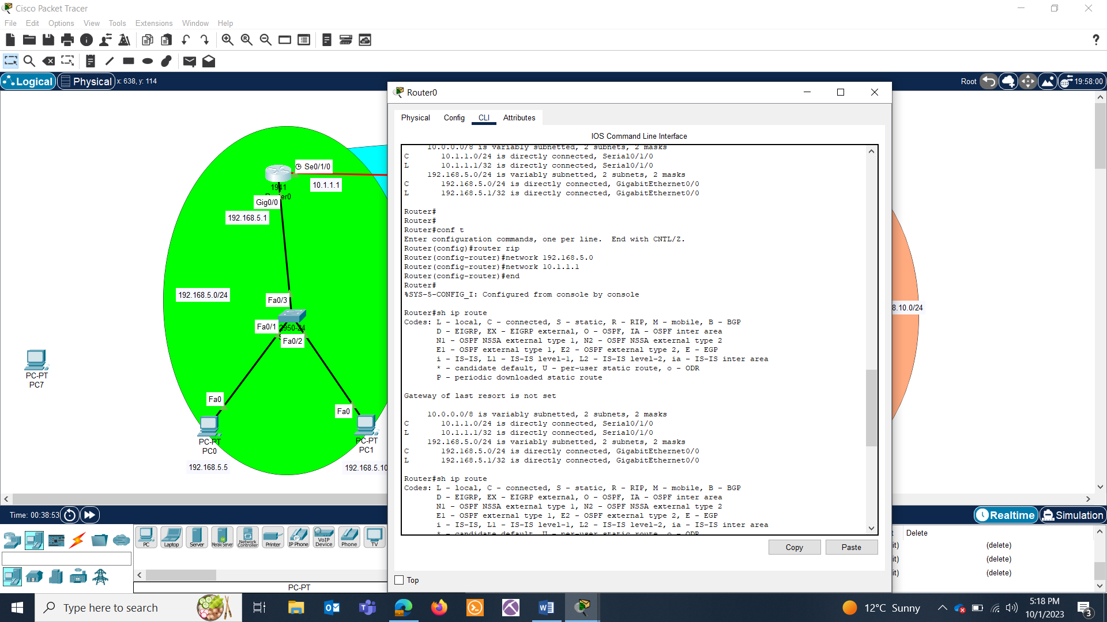

Router1:

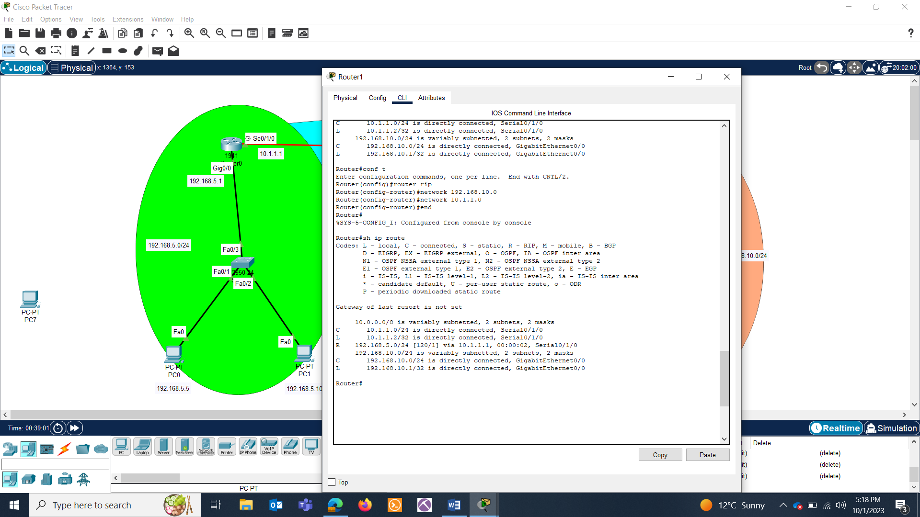

Lets see the routes:

Router0:

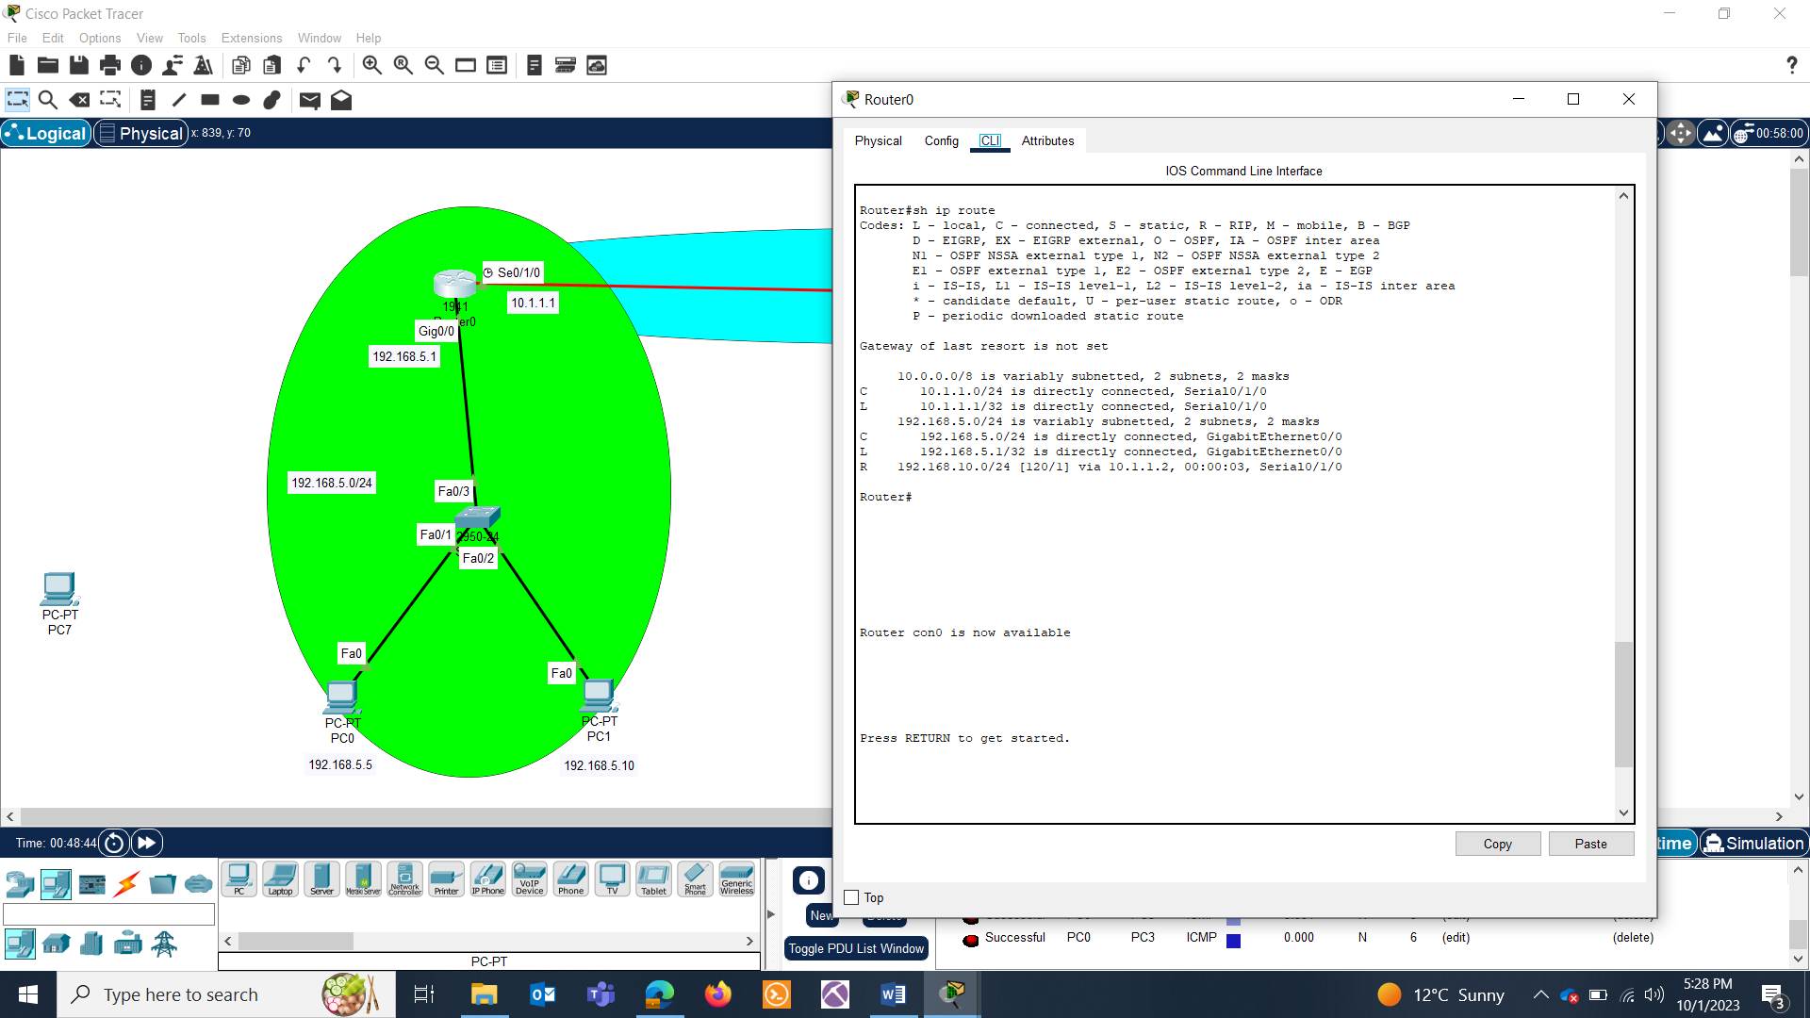

Router1:

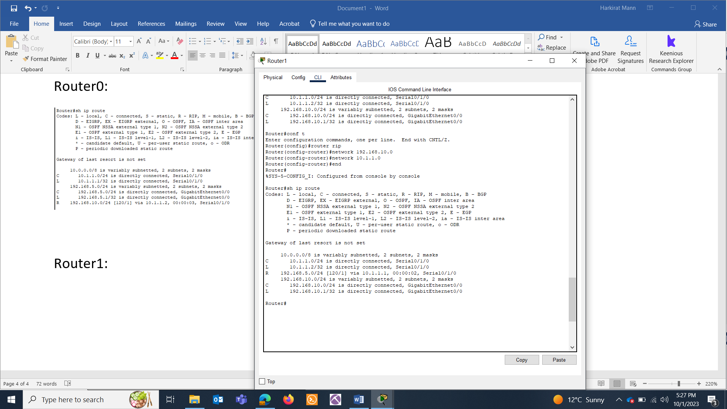

Now try sending packets in btw different networks and you’ll see the success message.

**OSPF:**

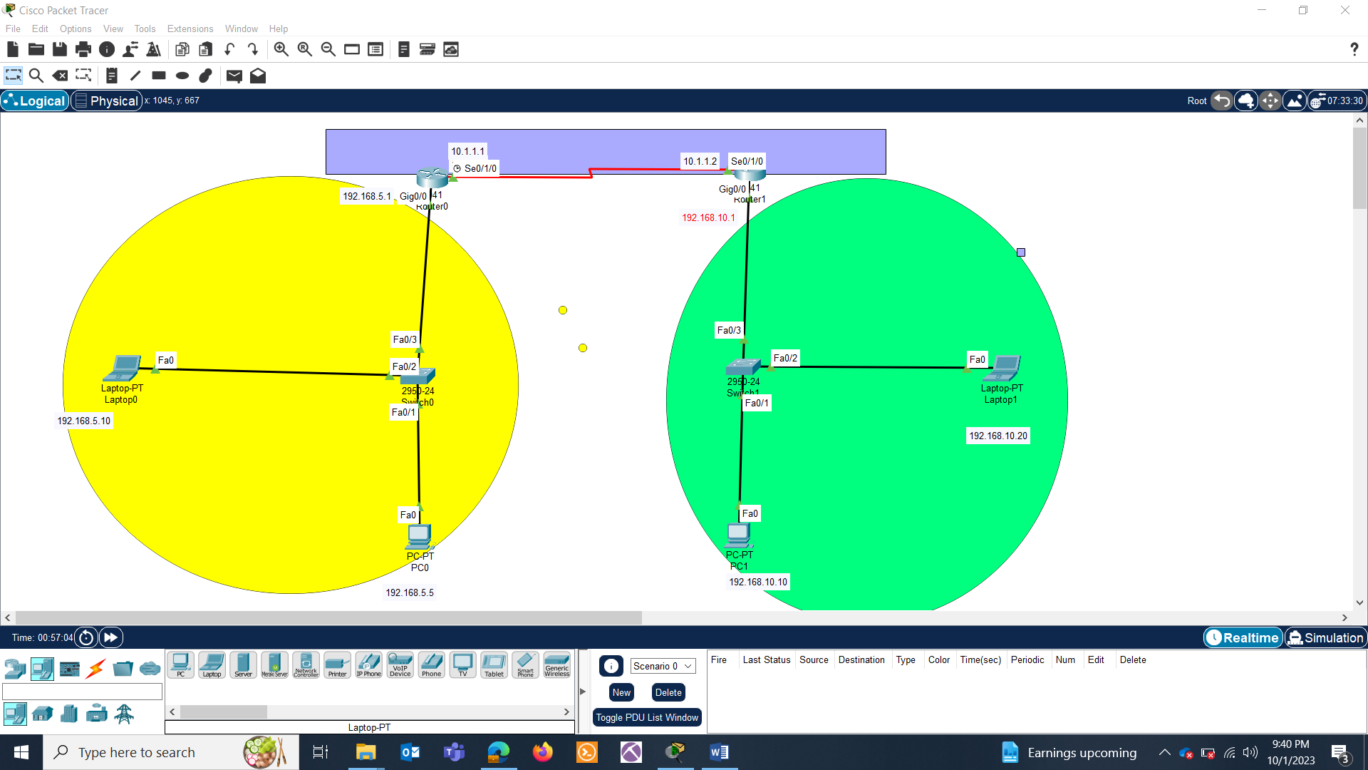

**PC CONFIGURATIONS:**

|  |  |  |  |  |
| --- | --- | --- | --- | --- |
| S.NO | Device | IPv4 | Subnet mask | Default Gateway |
| 1 | PC0 | 192.168.5.5 | 24 | 192.168.5.1 |
| 2 | PC1 | 192.168.10.10 | 24 | 192.168.10.1 |

**LAPTOP CONFIGURATIONS:**

|  |  |  |  |  |
| --- | --- | --- | --- | --- |
| S.NO | Device | IPv4 | Subnet mask | Default Gateway |
| 1 | Laptop0 | 192.168.5.10 | 24 | 192.168.5.1 |
| 2 | Laptop1 | 192.168.10.20 | 24 | 192.168.10.1 |

**ROUTER CONFIGURATION:**

|  |  |  |  |  |
| --- | --- | --- | --- | --- |
| S.NO | Device | Interface | IPv4 address | Subnet mask |
| 1 | Router0 | Gig0/0 | 192.168.5.1 | 24 |
| Se0/1/0 | 10.1.1.1 | 8 |
| 2 | Router1 | Gig0/0 | 192.168.10.1 | 24 |
| Se0/1/0 | 10.1.1.2 | 8 |

TASK : Ping inside the network and then outside the network.

Use the following commands to enable OSPF Routing on Cisco Routers to communicate the two segments to each other.

R0:

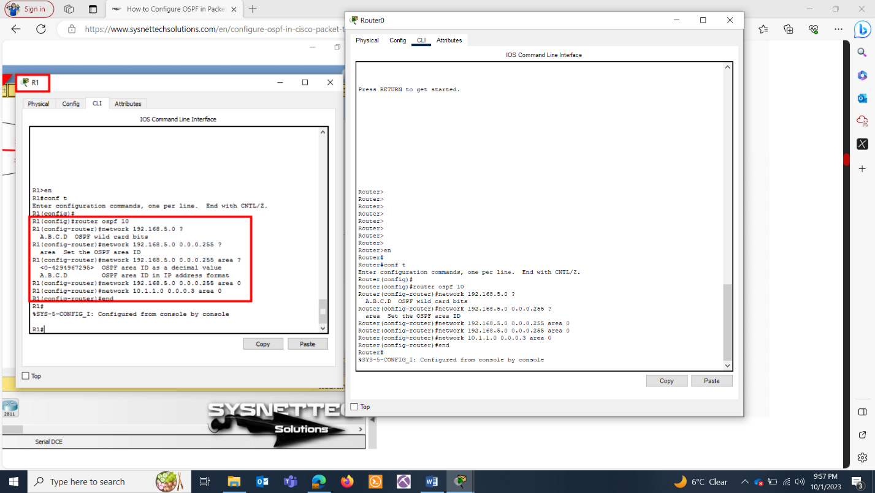

Execute the **show ip route ospf 10** command on Router0 and examine the routing table.

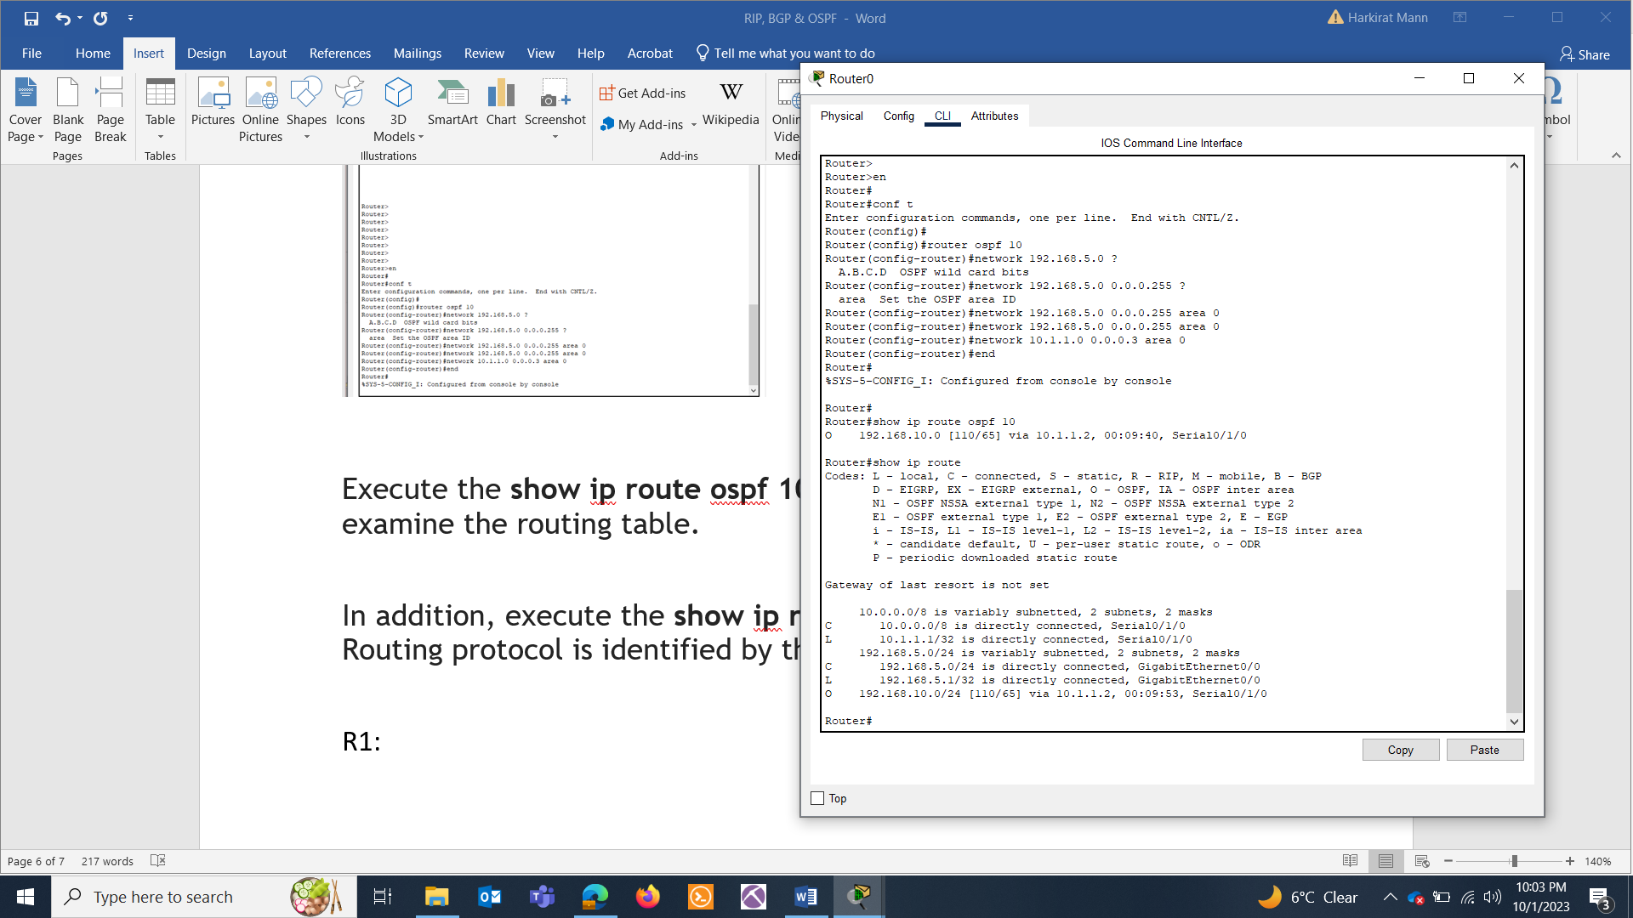

**show ip route** command to see that the Routing protocol:

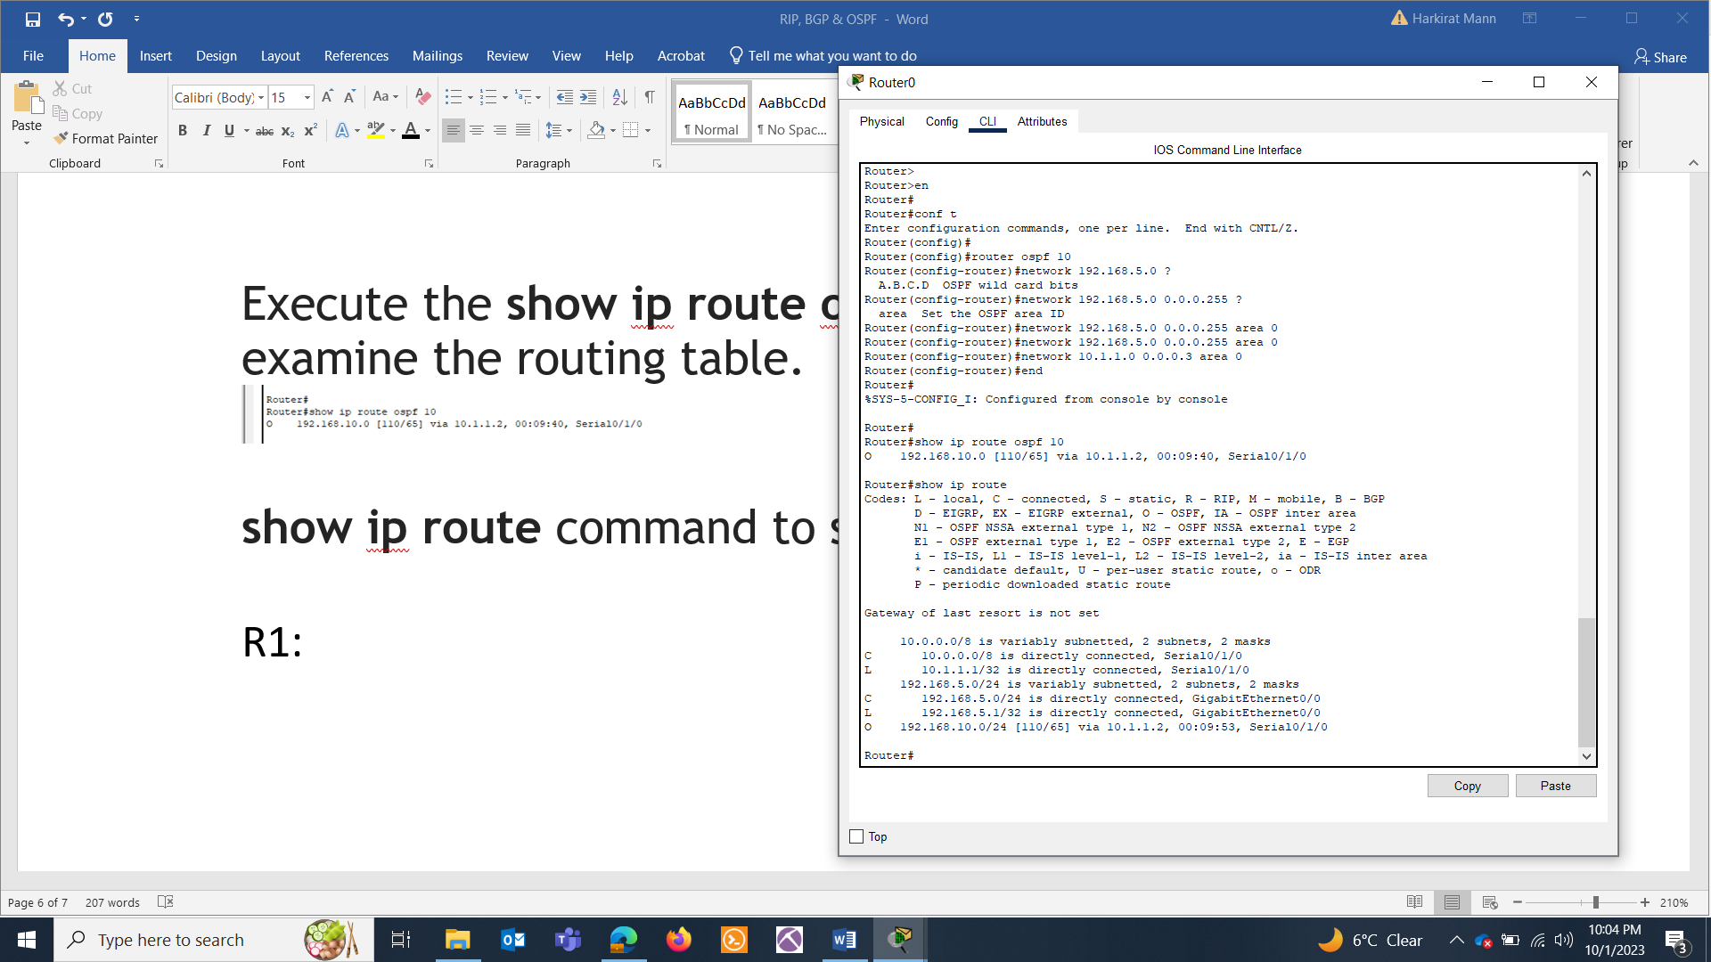

Ping the hosts of other network

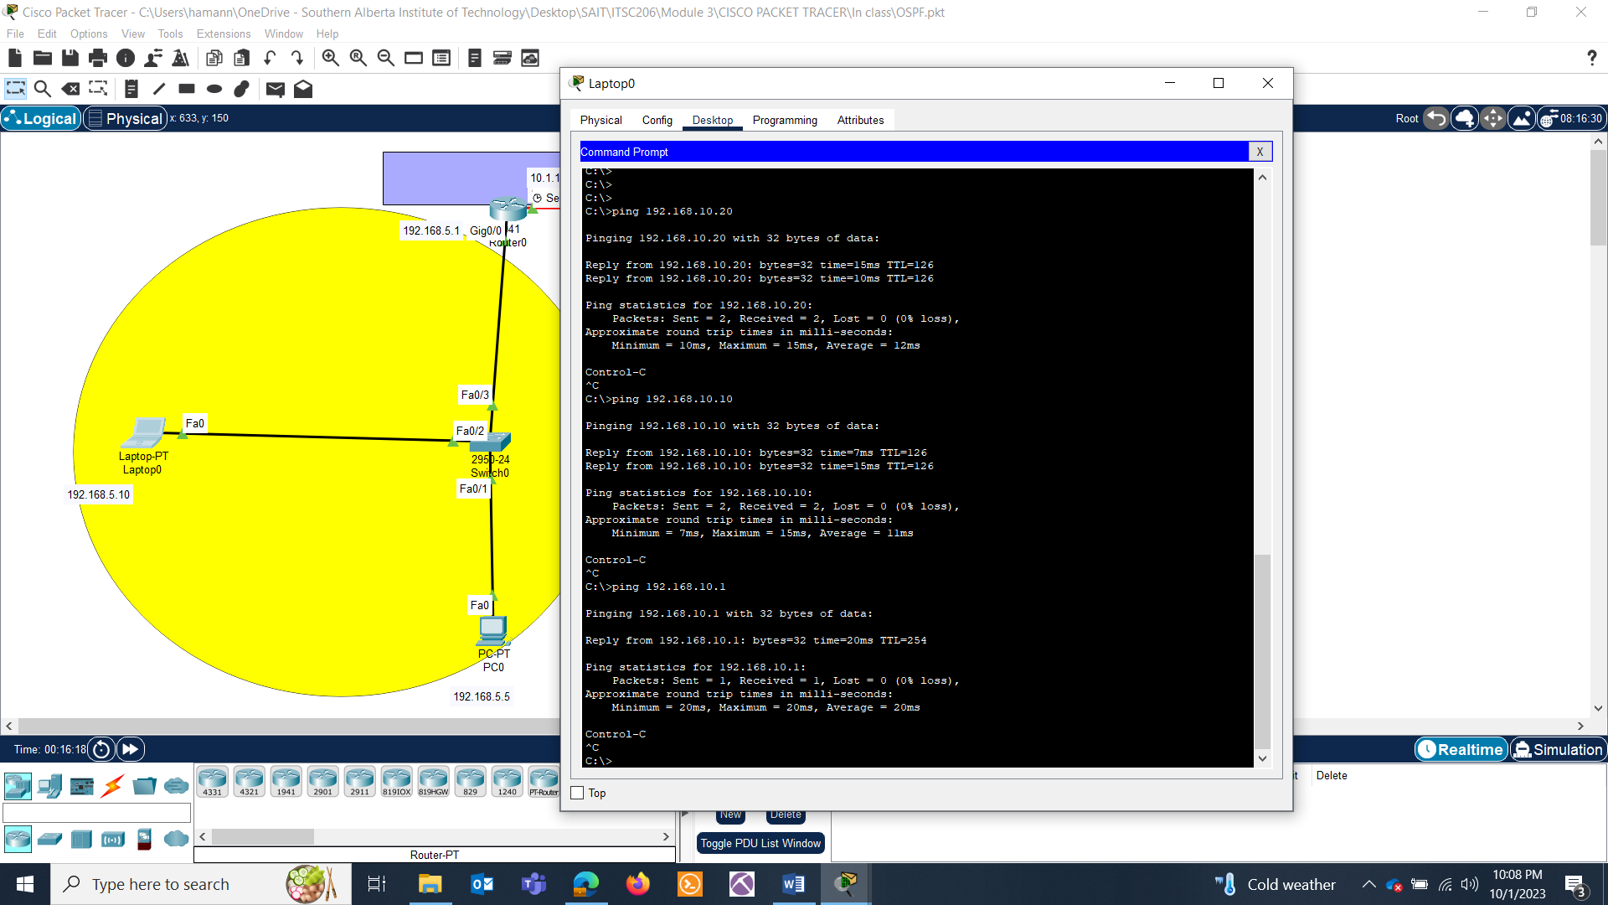

SHOW COMMANDS:

* Show ip ospf database

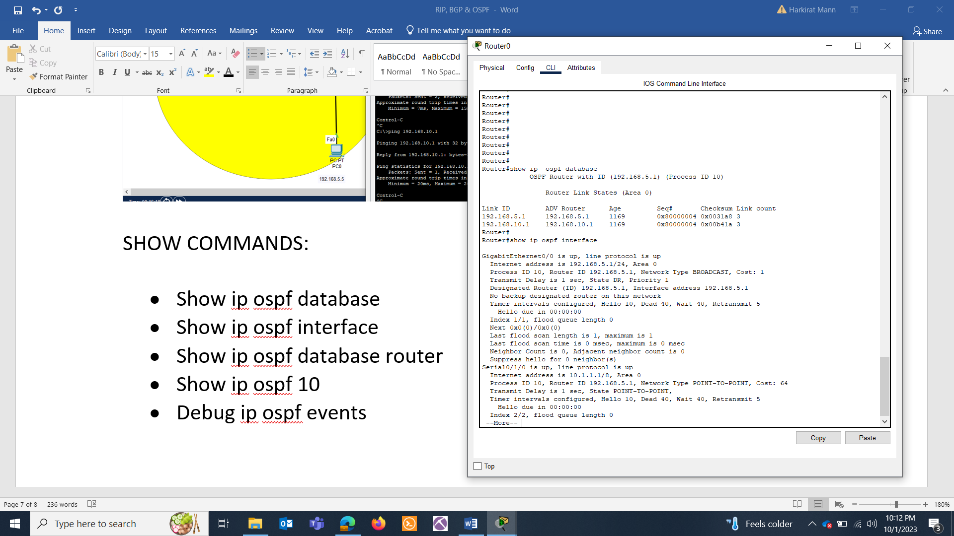

* Show ip ospf interface



* Show ip ospf database router

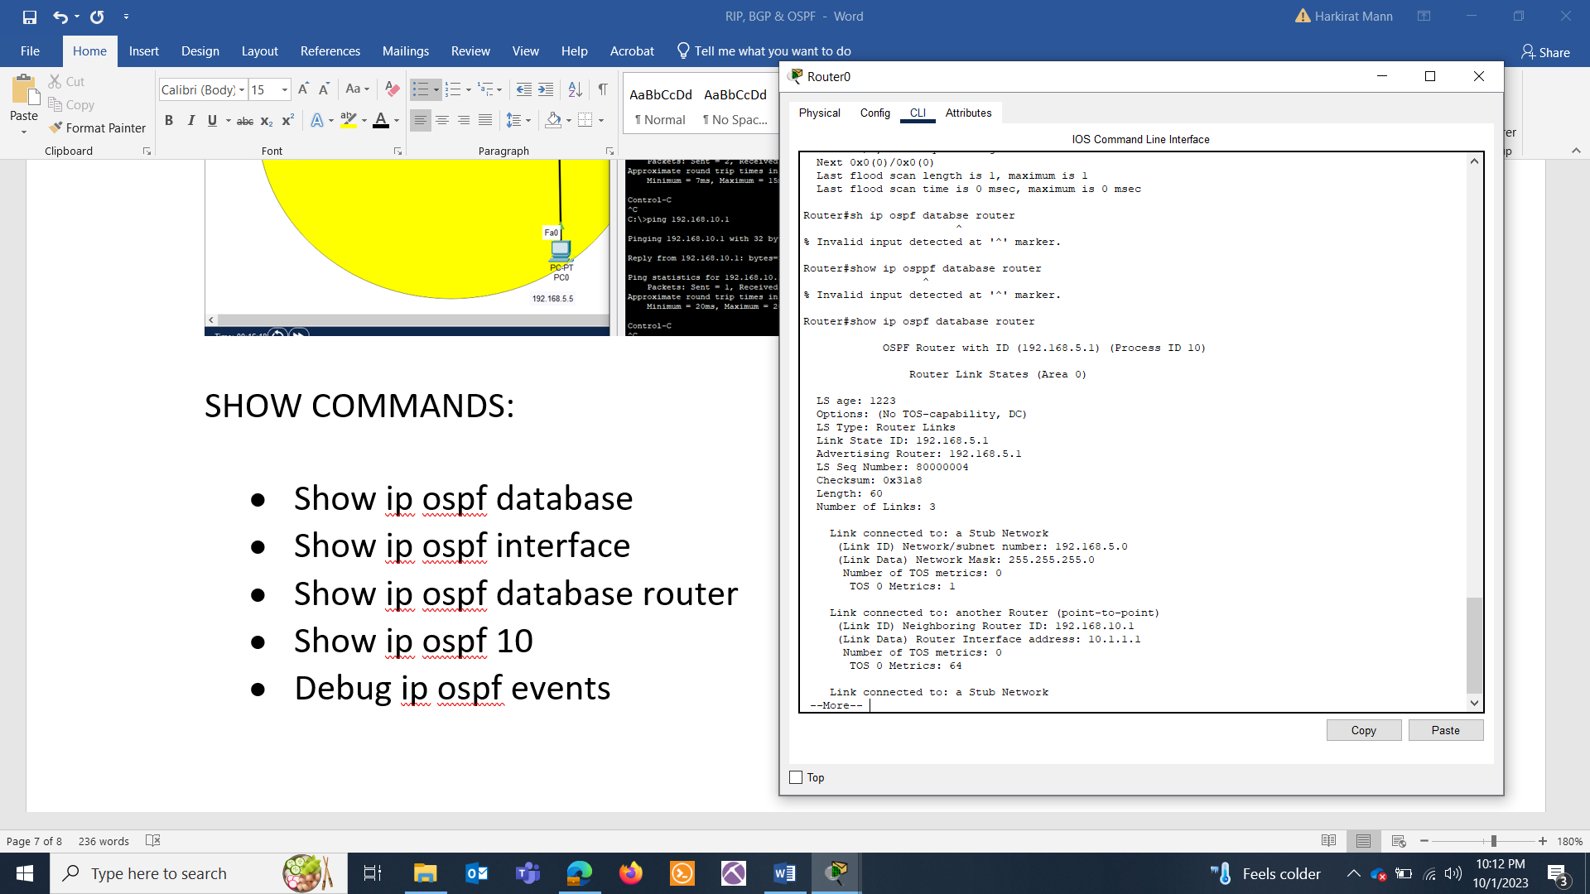

* Show ip ospf 10

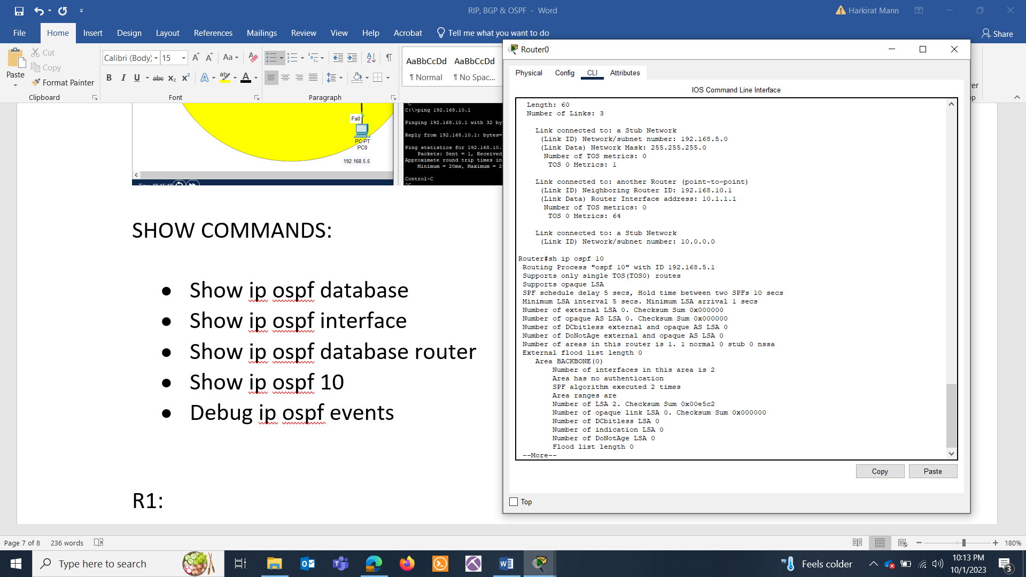

* Debug ip ospf events

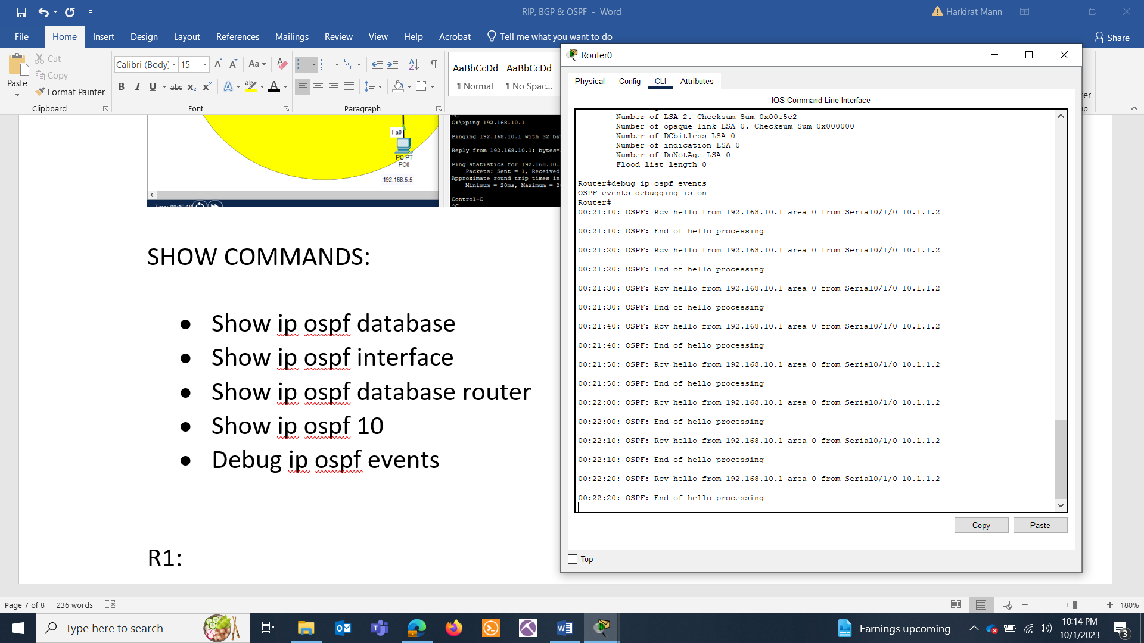

That’s all for one router. Repeat everything for the other.

R1:

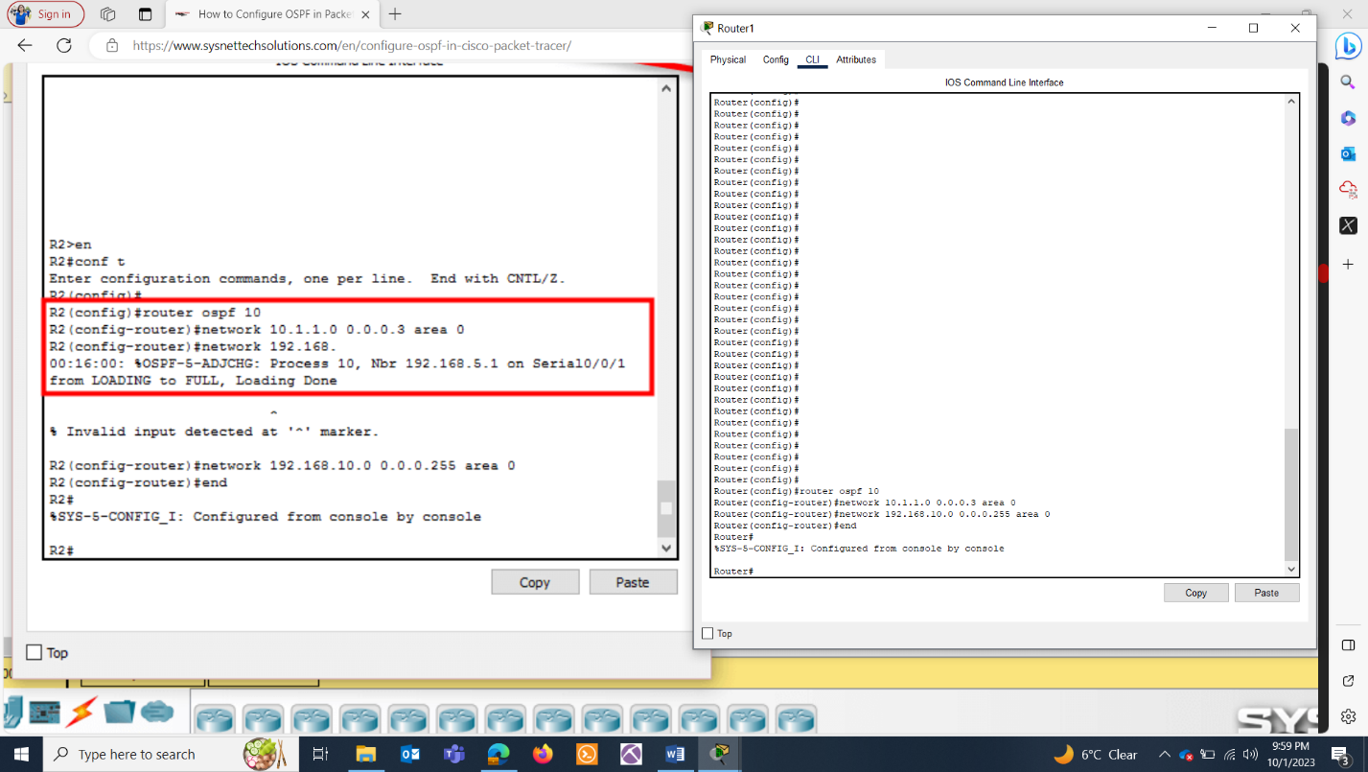

Repeat show commands, sh ip route.

**BGP**

CREATE THIS TOPOLOGY:

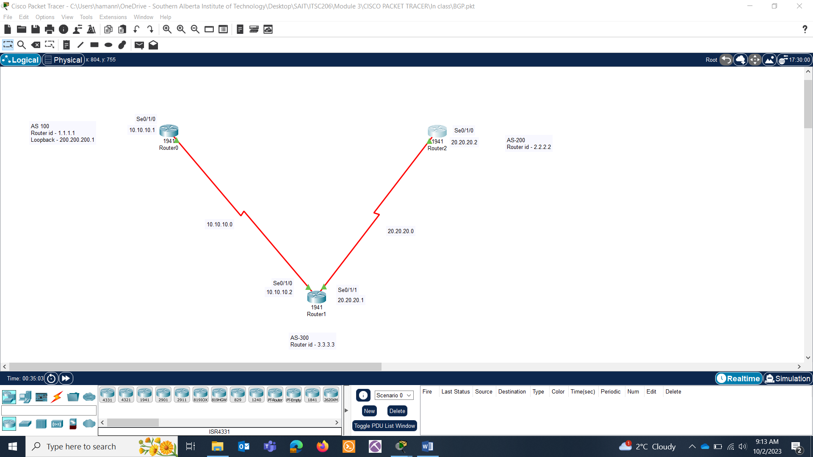

Kindly allocate the ip addresses as per the topology

ROUTER0:

Loopback addresses:

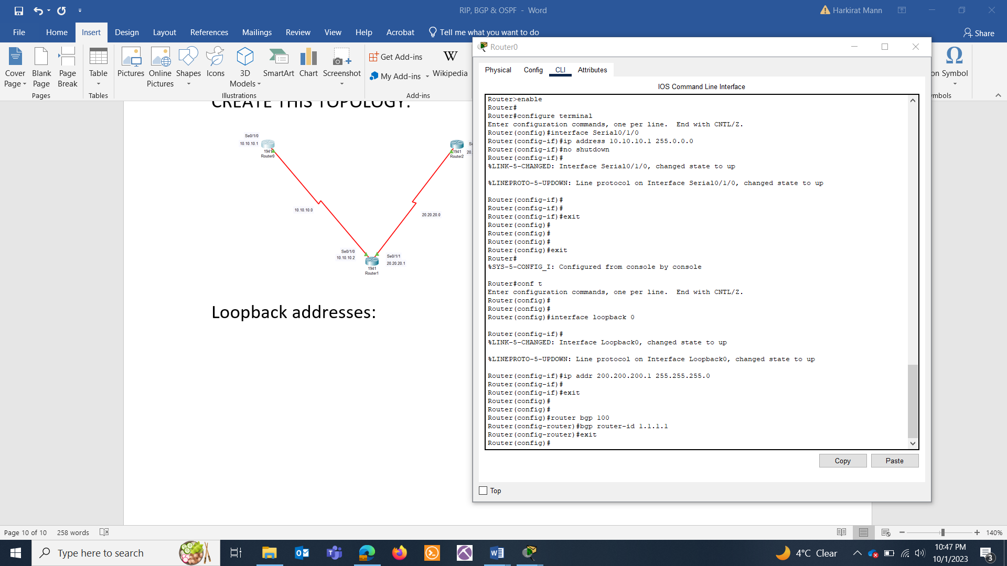

Setting bgp:

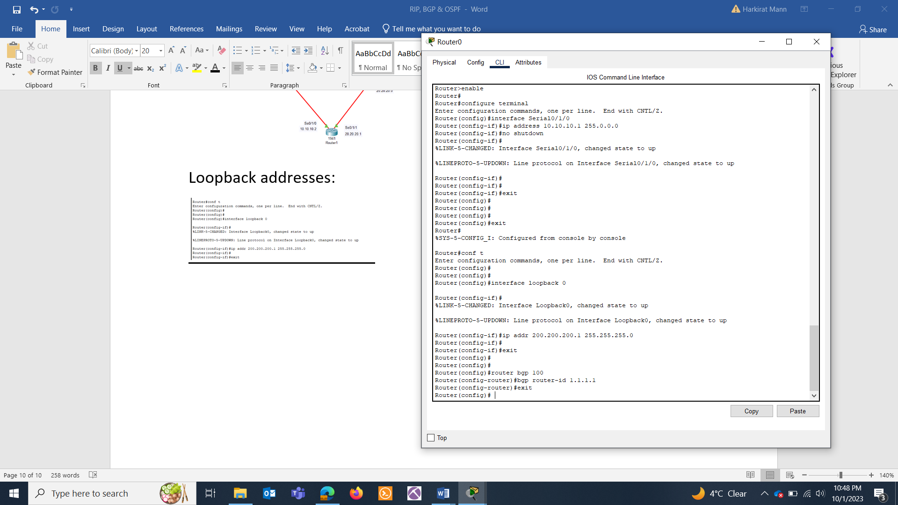

**ROUTER1:**

**No lookpback address.**

BGP setup:

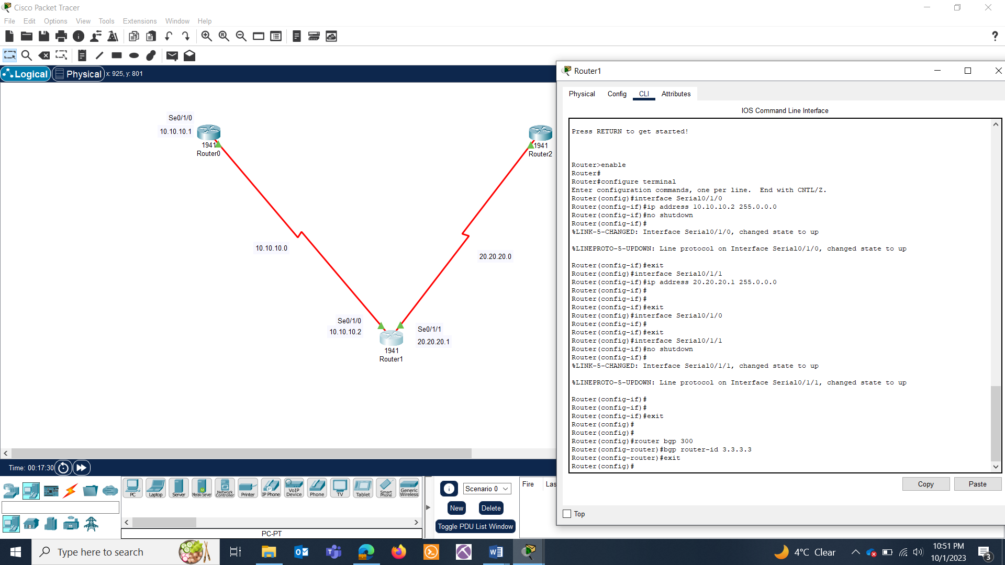

**Router2:**

No loopback address, BGP setup:

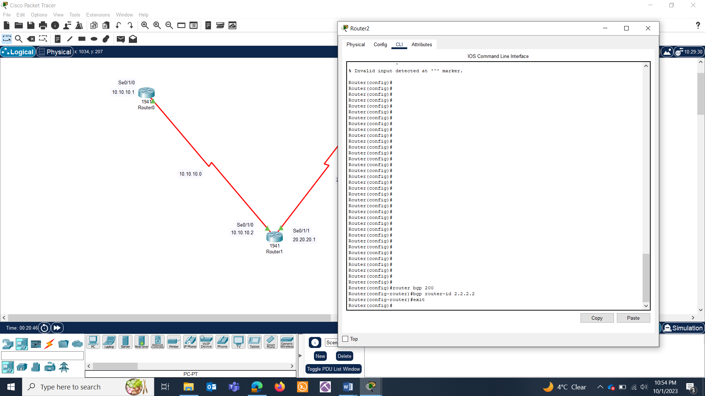

**SETTING NEIGHBORS:**

**Router0:**

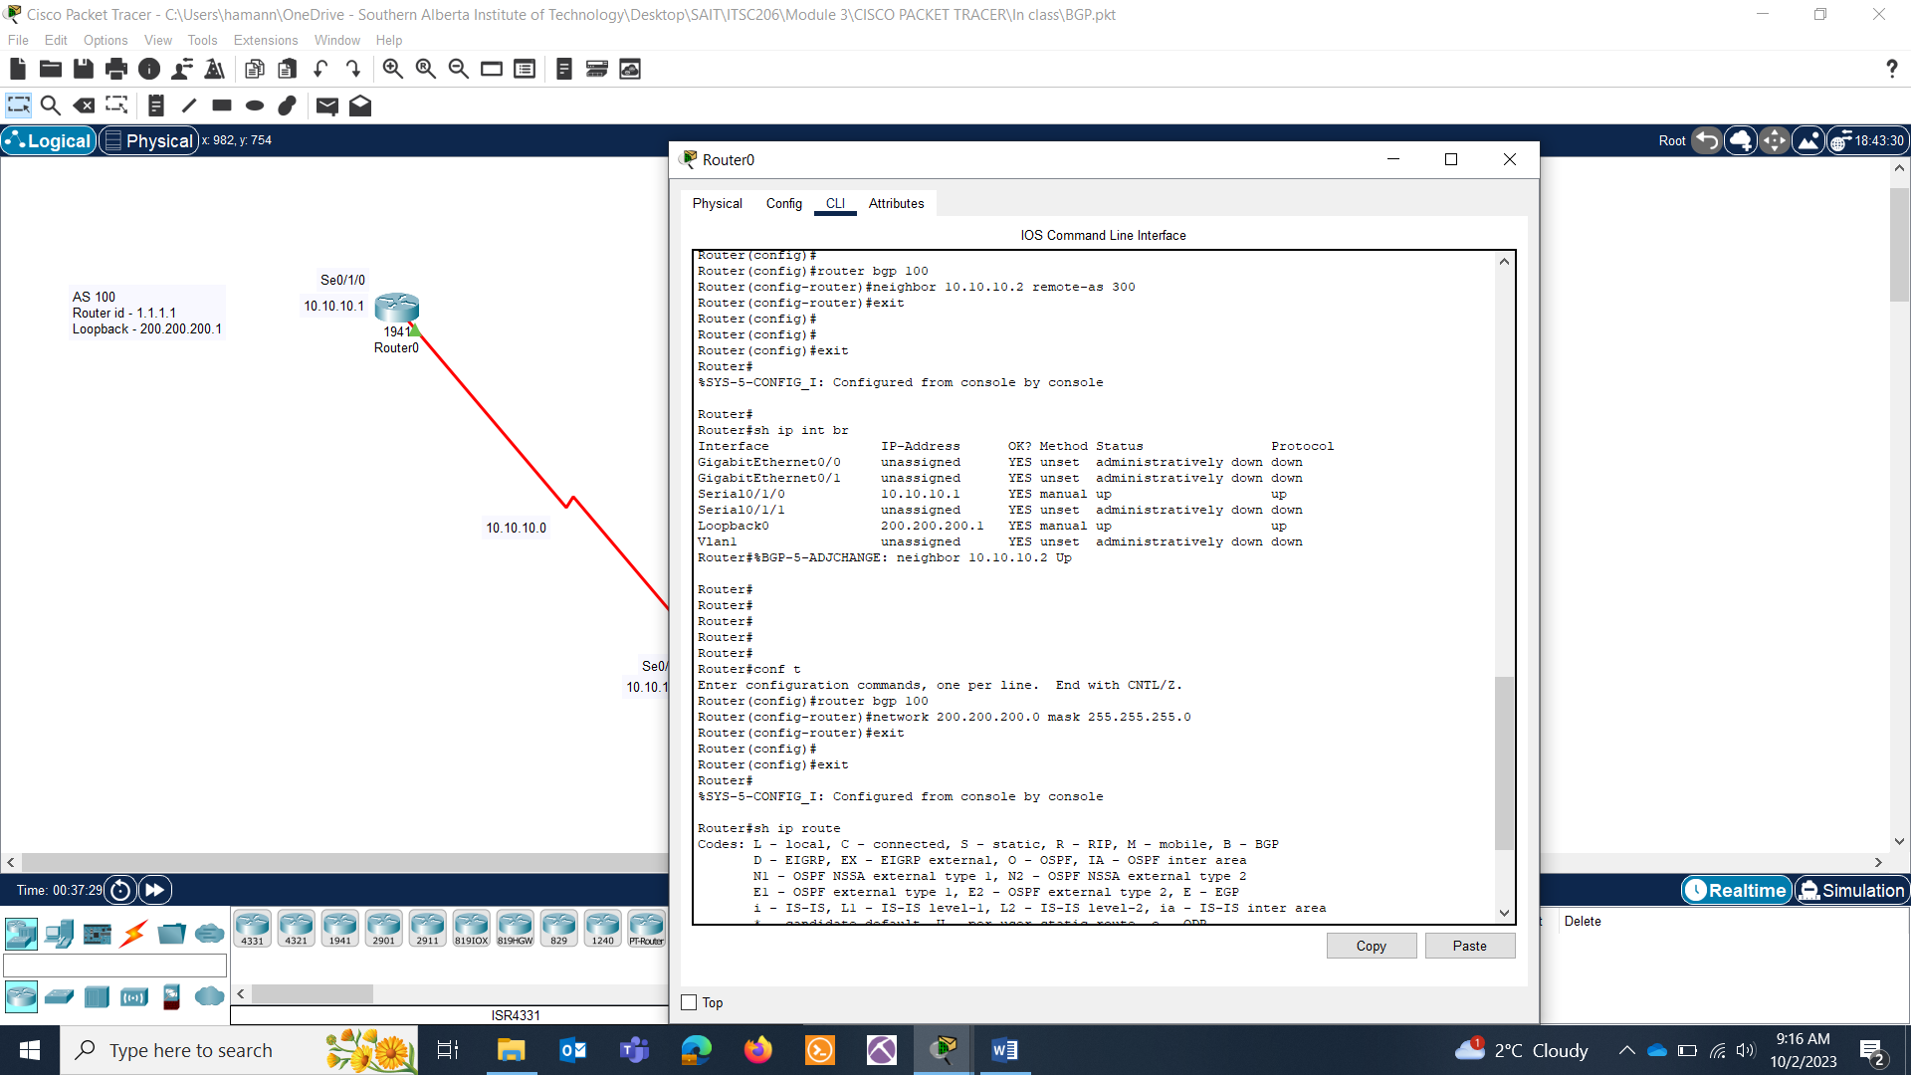

**Router1:**

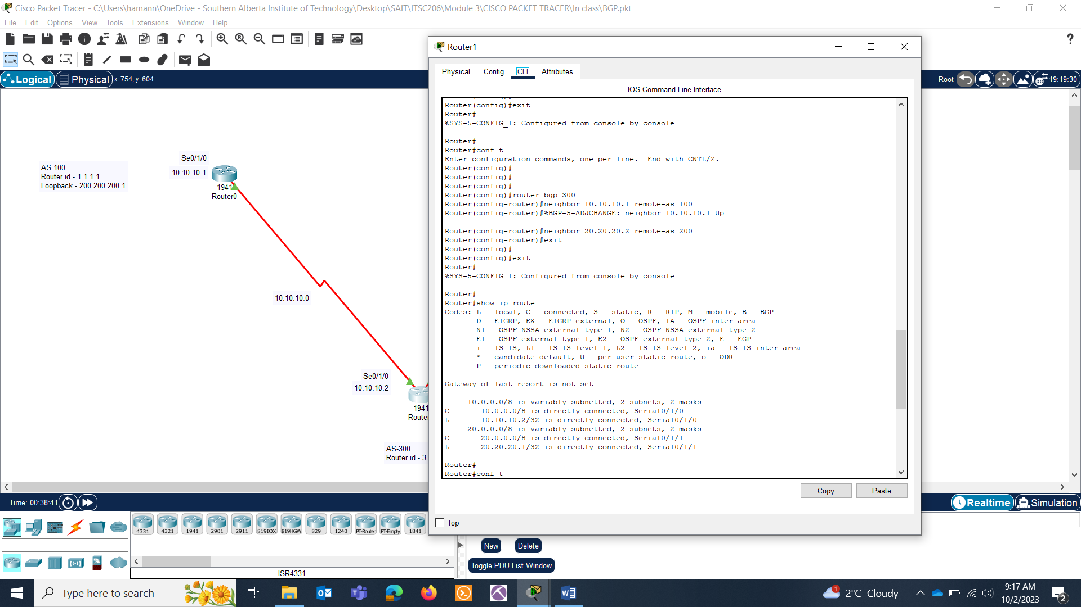

**Router2:**

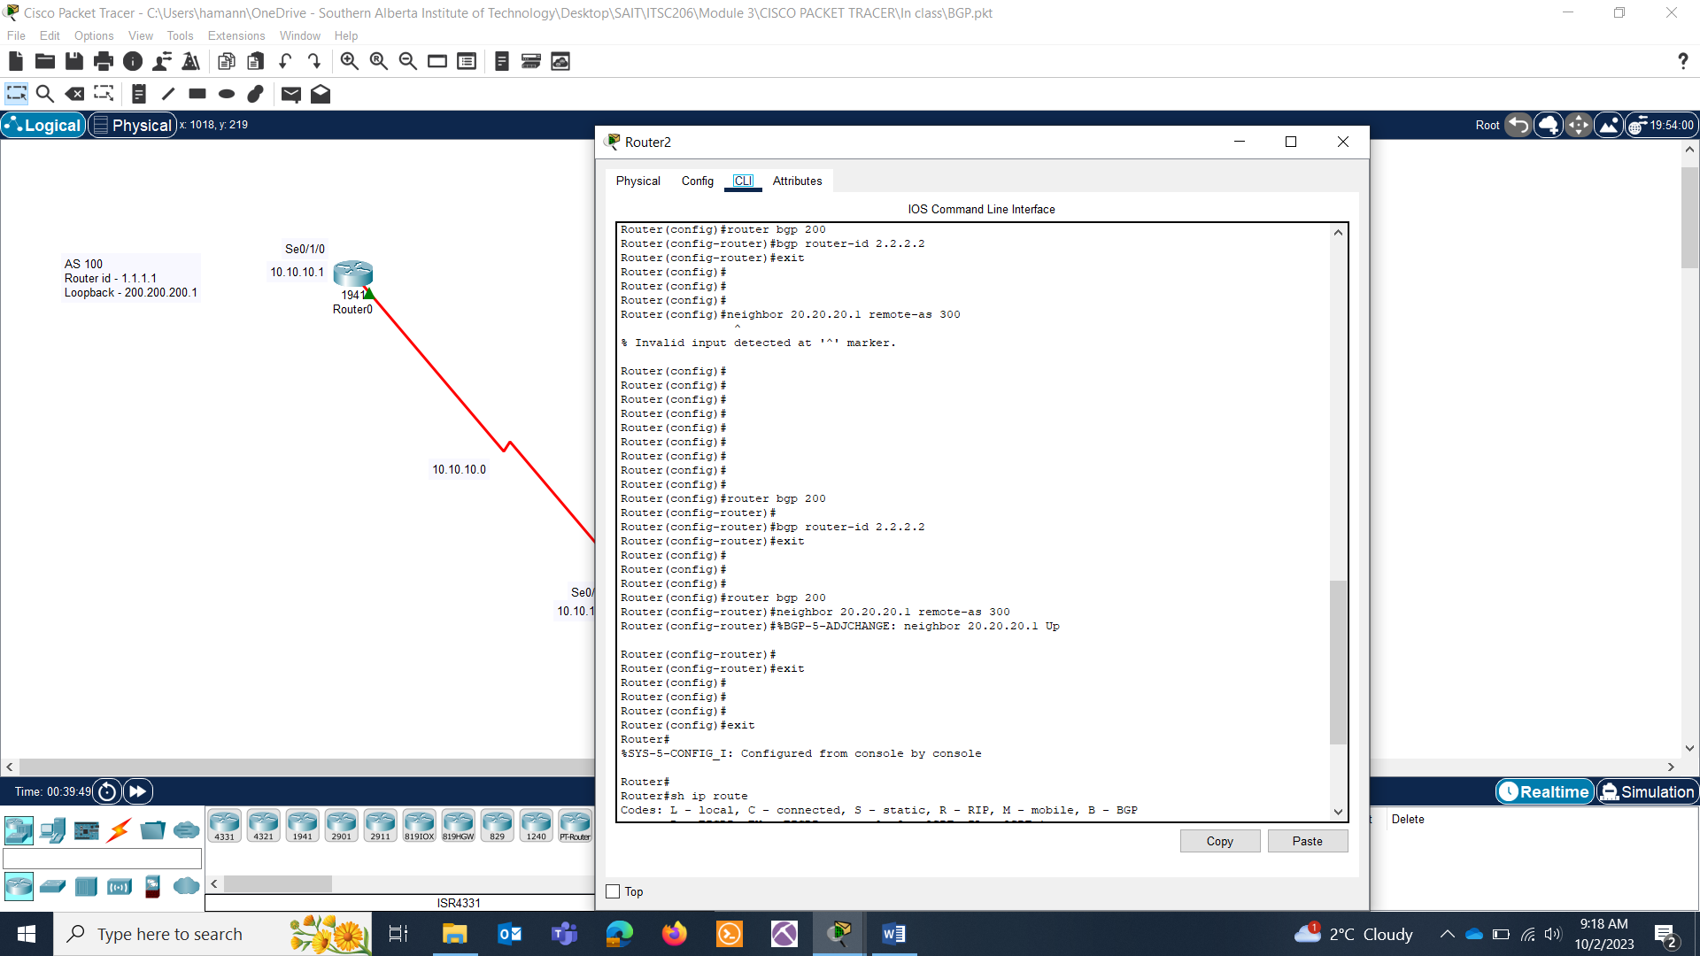

**Adding a network in the topology on Router0:**

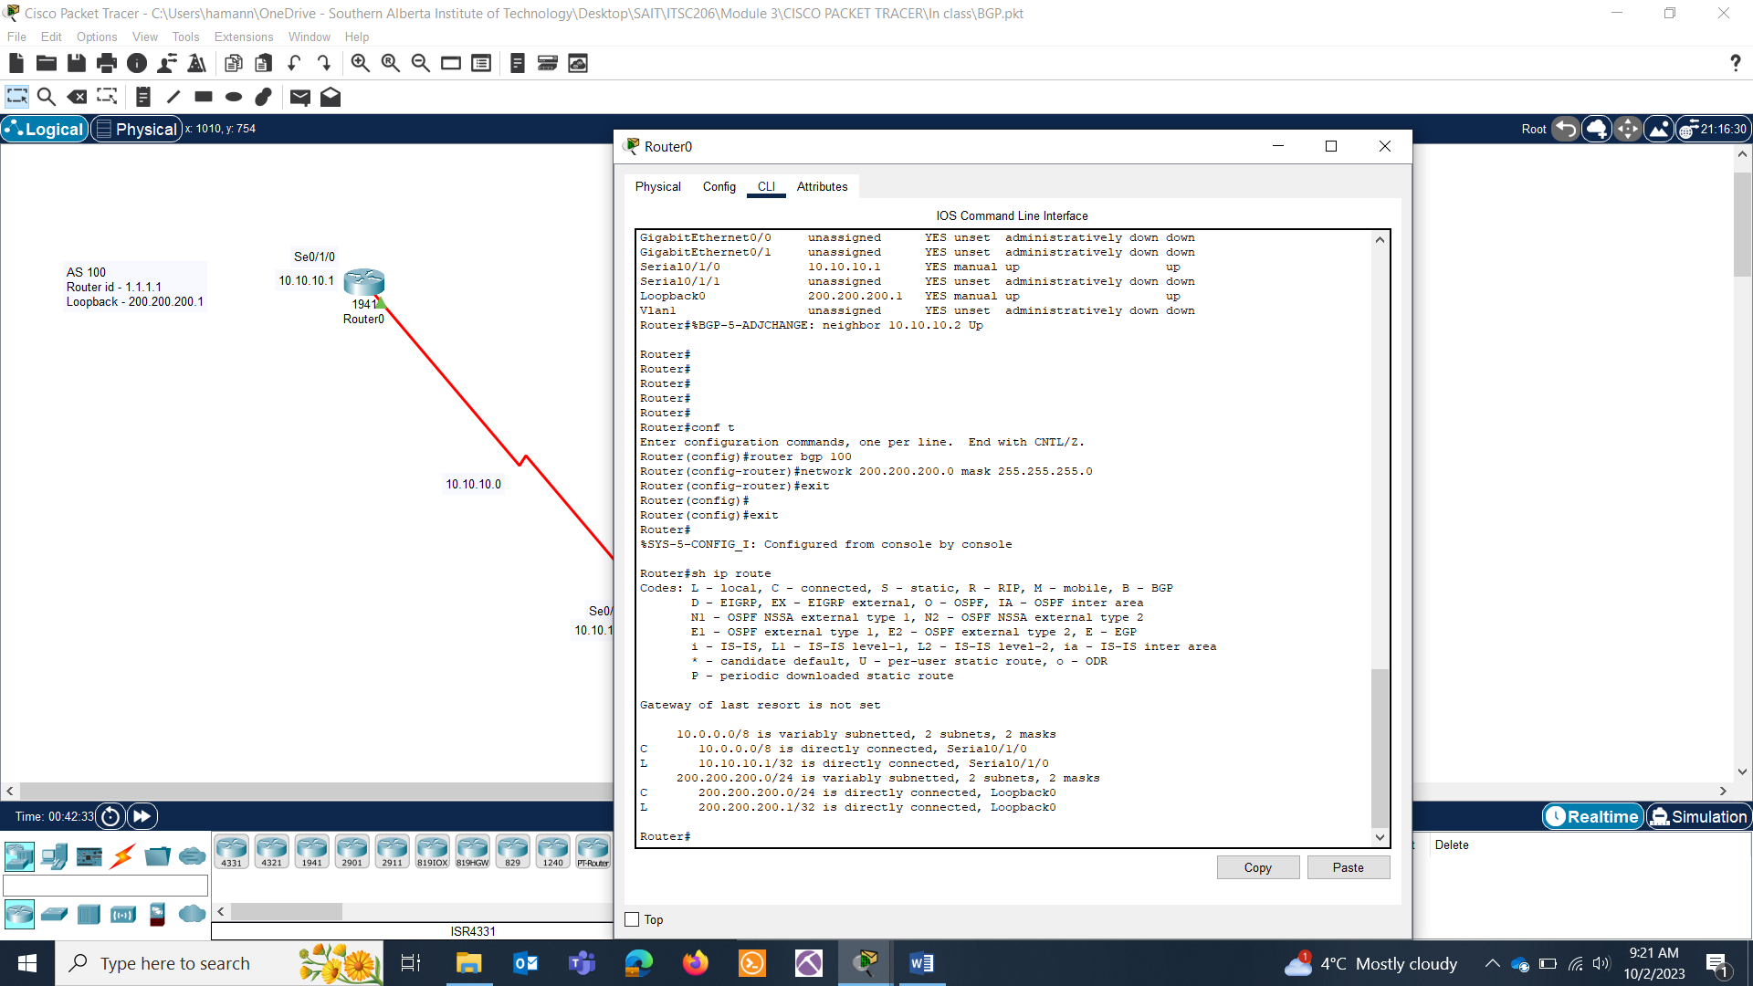

**Checking routes :**

**Router0:**



**Router1:**

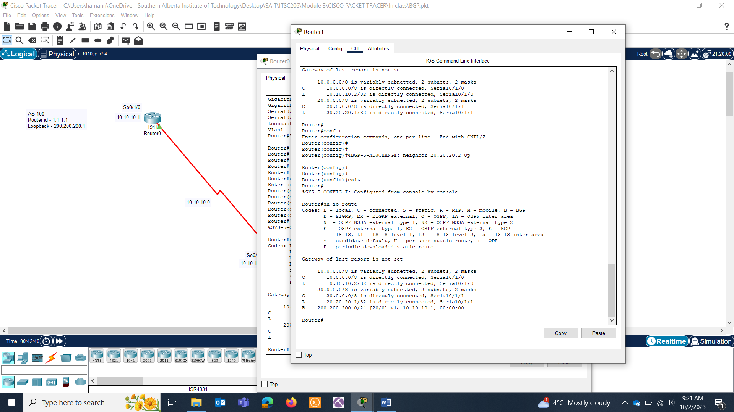

**Router2:**

